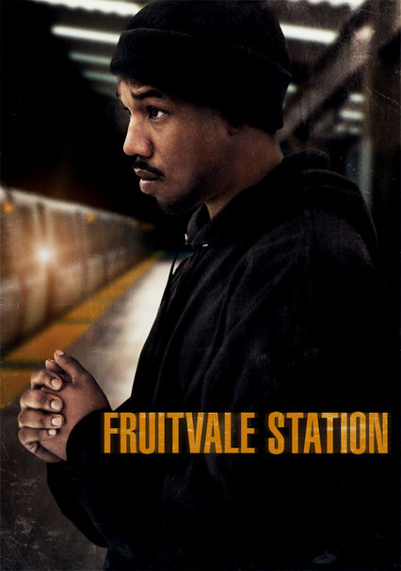
AGENDA

OBS | Fruitvale Station Writers Group

Date Sunday, June 28th, 2020

2:00PM PST/ 4:00PM CST/ 5:00PM EST – 3:30PM PST/ 5:30PM CST/ 6:30PM EST
https://www.uberconference.com/obswritersgroup | Optional dial-in number: 323-347-7898

Meeting called by Moderator: Jana M. Gamble

Attendees: | Fruitvale Station Writers Group Members Only
Please read: | Agenda & Group Guidelines prior to Meeting
Please bring: | A great attitude, note taking devices, your writing goals and questions
2:00 – 2:10 | Meeting Introduction  Personal & Mental Health Check-In | 1 minute each
2:10 – 2:50 | New Members & Group Information  Introductions  Spreadsheet Share  Needs Assessment  Individual Writing Goals
2:50 – 3:00 | OBS Site  News, Navigation & Usage Check
3:00 – 3:15 | 2020 – 2021 Cycle  Labs, Workshops & Programs
3:15 – 3:25 | It Takes A Village  Strengths & Challenges | 1 minute each
3:25 – 3:30 | Q & A | July Conference
Important Information: | This platform source is a one-time use only. | July Conference:  3rd Sunday @TBD
Moderator: Jana M. Gamble | 314.349.0640 & 314.776.8750 | PurposedProductions@gmail.com

