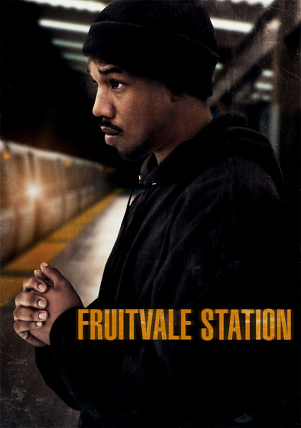
AGENDA

OBS | Fruitvale Station Writers Group

Date Sunday, May 31st, 2020

6:00PM CST/ 4:00PM PST – 8:00PM CST/ 6:00PM CST
https://us02web.zoom.us/j/82635488790

Meeting called by Moderator: Jana M. Gamble

Attendees: | Fruitvale Station Writers Group Members Only
Please read: | Agenda & Group Guidelines prior to Meeting
Please bring: | A great attitude, note taking devices, your writing goals and questions
6:00 – 6:10 | Meeting Introduction  Personal Check-In | 2-3 minutes each
6:10 – 6:40 | Sundance Submissions  Tasks Check-In  Needs Assessment
6:40 – 7:10 | Zaddy & Meeting On Purpose Script Coverage  Group Review
7:10 – 7:15 | OBS Site  Navigation & Usage Check
7:15 – 7:25 | 2020 – 2021 Cycle  Labs, Workshops & Programs
7:25 – 7:45 | It Takes A Village  Strengths & Challenges | 2 minutes each
7:45 – 8:00 | Q & A

Important Information:
This platform source is a one-time use only. We will move to an established OBS Video Conference Option.

