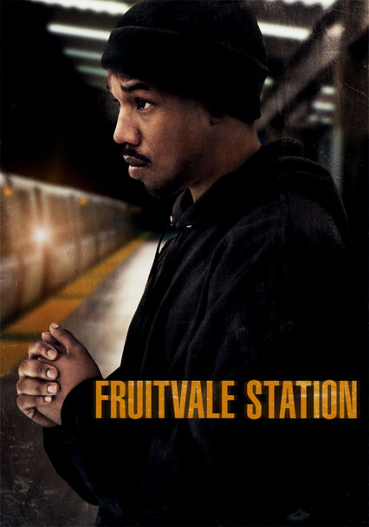
  - Fruitvale Station Writers Group
Virtual Conference
Sunday, April 19, 2020 | 6:00-7:30pm CST

Attendees: Jana, Marquis, Tony, Yvette, Livingston

Topics Covered: Introductions + Strengths & Challenges, OBS Orientation, Expectations & Guidelines, Tasks + Writing Goals, OBS Site Navigation, 2020-2021 Cycle

Takeaways:
- Everyone successfully logged in and is well!
- We have an amazing group of writers with varying experience
- Marquis and Yvette have previously submitted work to programs/festivals
- We are all in this together
- Marquis shared list with more contests. They have been added to the master list in our group docs.
- Marquis shared 2 beneficial resources he uses- Anatomy of Story and The Nutshell Technique. We now have a folder of additional resources and links in our group docs. The charts are also available.
- Our writing processes vary. We discussed the use of the Notes and Feedback Requests to help us move forward.
- Each of us need to take time to review the numerous writing fellowships/labs/festivals etc. to identify specific opportunities, so that we can prepare our materials effectively. This will allow Moderator to create effective tasks for your journey.
- Yvette - only member with representation. Has Agent – seeking Manager/Producer
- Tasks will be created for each meeting attendee based on information provided
- Don’t forget to share the link provided to Moderator after submitted request for coverage
- If any group member has questions or needs please send Jana a direct message
- Keep up the great work!

Next Virtual Conference: Sunday, May 17th, 2020 at 6:00pm CST / 4:00pm PST

